Test Case for OldPhonePad Console Application

Run the OldPhonePadConsole.

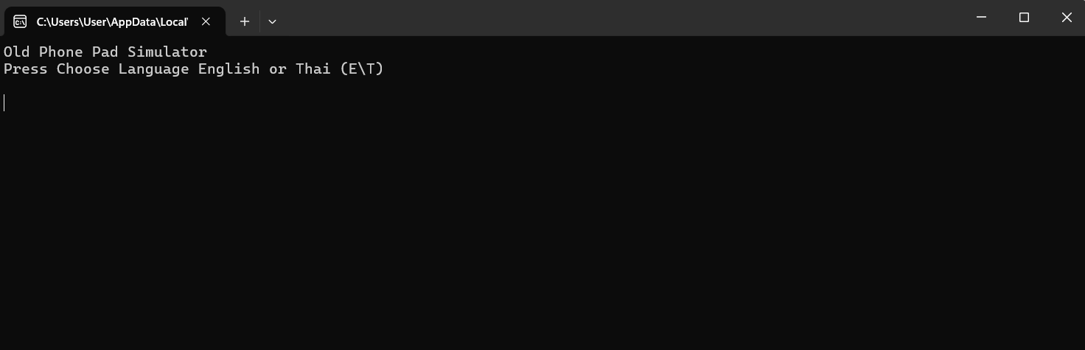

Enter Input either ‘E’, ‘e’ or ‘T’,’t’ to choose the language.

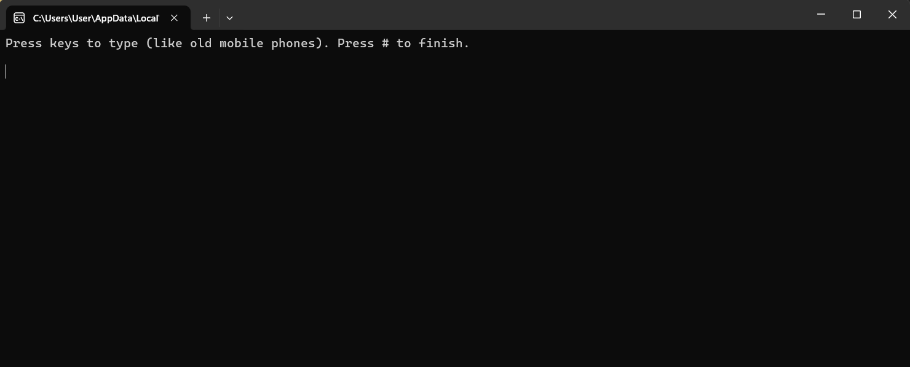

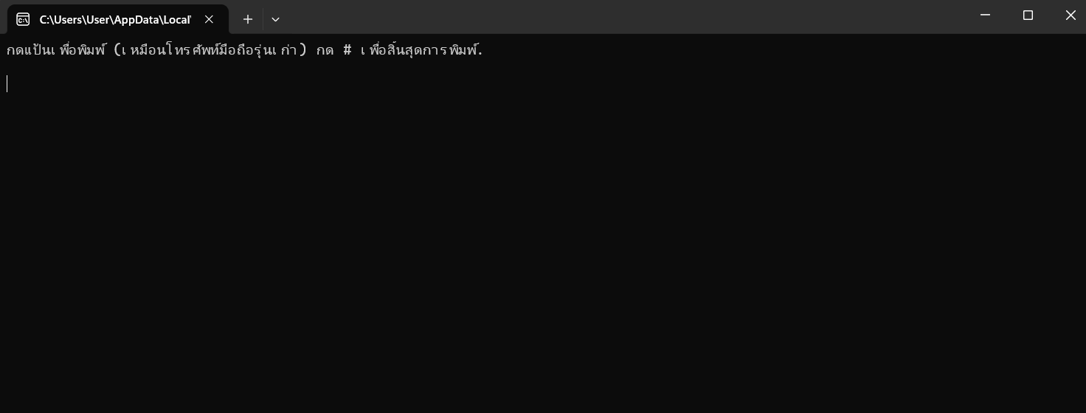

Enter Input and end with ‘#’.

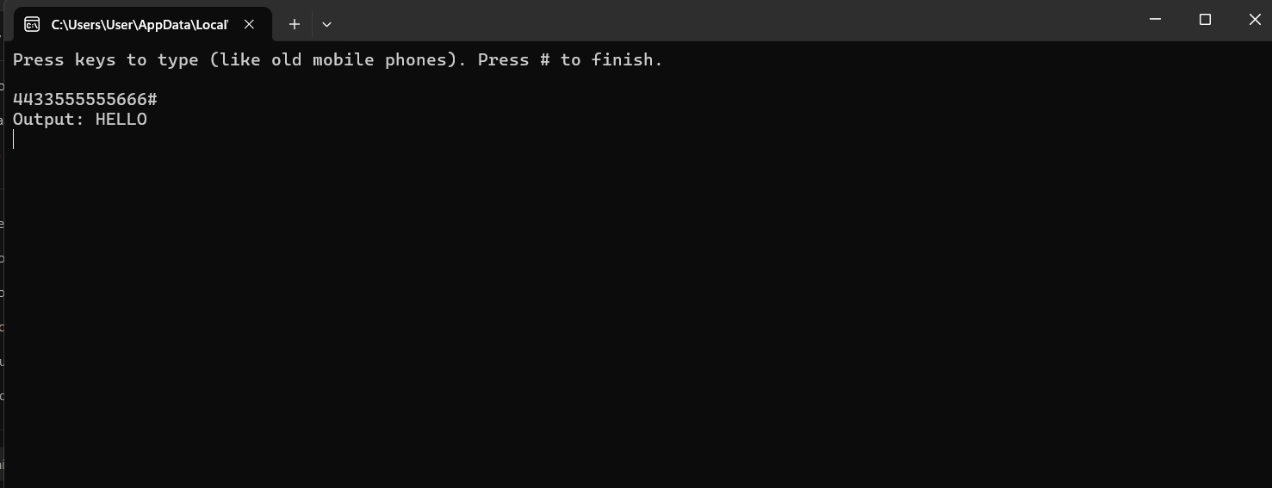

Enter same number 2 times and 3 times to get 2nd and 3rd and 4th character from Phone pad .

Enter No 1 for special charater like &, ‘ , ( , ) and 0 for space .

Unit testing

Go to Test >> Test Explorer >> run all test

